

Cambium Networks

PLANNING AND INSTALLATION GUIDE

ePMP 4600L

##### Reservation of Rights

Cambium reserves the right to make changes to any products described herein to improve reliability, function, or design, and reserves the right to revise this document and to make changes from time to time in content hereof with no obligation to notify any person of revisions or changes. Cambium recommends reviewing the Cambium Networks website for the latest changes and updates to products. Cambium does not assume any liability arising out of the application or use of any product, software, or circuit described herein; neither does it convey license under its patent rights or the rights of others. It is possible that this publication may contain references to, or information about Cambium products (machines and programs), programming, or services that are not announced in your country. Such references or information must not be construed to mean that Cambium intends to announce such Cambium products, programming, or services in your country.

##### Copyrights

This document, Cambium products, and 3rd Party software products described in this document may include or describe copyrighted Cambium and other 3rd Party supplied computer programs stored in semiconductor memories or other media. Laws in the United States and other countries preserve for Cambium, its licensors, and other 3rd Party supplied software certain exclusive rights for copyrighted material, including the exclusive right to copy, reproduce in any form, distribute and make derivative works of the copyrighted material. Accordingly, any copyrighted material of Cambium, its licensors, or the 3rd Party software supplied material contained in the Cambium products described in this document may not be copied, reproduced, reverse engineered, distributed, merged or modified in any manner without the express written permission of Cambium. Furthermore, the purchase of Cambium products shall not be deemed to grant either directly or by implication, estoppel, or otherwise, any license under the copyrights, patents or patent applications of Cambium or other 3rd Party supplied software, except for the normal non-exclusive, royalty free license to use that arises by operation of law in the sale of a product.

##### Restrictions

Software and documentation are copyrighted materials. Making unauthorized copies is prohibited by law. No part of the software or documentation may be reproduced, transmitted, transcribed, stored in a retrieval system, or translated into any language or computer language, in any form or by any means, without prior written permission of Cambium.

##### License Agreements

The software described in this document is the property of Cambium and its licensors. It is furnished by express license agreement only and may be used only in accordance with the terms of such an agreement.

##### High Risk Materials

Cambium and its supplier(s) specifically disclaim any express or implied warranty of fitness for any high-risk activities or uses of its products including, but not limited to, the operation of nuclear facilities, aircraft navigation or aircraft communication systems, air traffic control, life support, or weapons systems (“High Risk Use”).

This product is not restricted in the EU. Any High Risk is unauthorized, is made at your own risk and you shall be responsible for any and all losses, damage or claims arising out of any High-Risk Use.

© 2025 Cambium Networks Limited. All rights reserved

# Contents

Contents 3

About This Guide 6

Problems and warranty6

Reporting problems6

Repair and service6

Warranty6

Security advice7

Precautionary statements7

Warning7

Federal Communication Commission Interference Statement7

IC Interference Statement8

Attention9

Note9

Caring for the environment9

In EU countries9

In non-EU countries10

Product Description 11

Overview of ePMP11

Purpose – ePMP portfolio11

ePMP 4600L11

Typical installation equipment12

Wireless operation12

MIMO13

Time-division duplexing13

Adaptive modulation13

Radar avoidance13

Encryption14

Country codes14

Further reading on wireless operation14

System management14

Management agent14

Webserver15

SNMP15

Network Time Protocol (NTP)15

Software upgrade16

Further reading on system management16

System Hardware 17

Site planning17

Site installation17

Grounding and lightning protection17

Lightning protection zones19

Electromagnetic Compatibility (EMC) compliance20

ePMP 4600L Access Point21

Description21

Part numbers22

Mounting bracket23

Interfaces23

Specifications24

Heater24

Wind loading25

Installation26

Software packages28

Power supply28

Power supply description28

Power supply part numbers29

Power supply interfaces30

Power supply specifications30

Power supply location considerations31

Ethernet cabling31

Ethernet standards and cable lengths31

Outdoor Cat5e cable32

Surge suppression unit32

Gigabit Ethernet Surge Suppressor33

Regulatory Information 34

General wireless specifications34

Regulatory limits34

Conforming to the limits35

Available spectrum35

Channel bandwidth35

Electromagnetic Compatibility (EMC) compliance35

Compliance with safety standards36

Glossary 37

Cambium Networks 39

# About This Guide

This guide describes the planning, installation, configuration, and operation of the Cambium ePMP Series of point-to- multipoint and point-to-point wireless Ethernet systems. It is intended for use by the system designer, system installer, and system administrator.

This section contains the following topics:

* Problems and warranty
* Security advice
* Precautionary statements

* Caring for the environment

## Problems and warranty

### Reporting problems

Cambium Networks offers comprehensive support to ensure optimal network performance, including training, online documentation, technical support, community forums, software downloads, warranty services, and repairs.

Through the Cambium Networks Support Center [https://support.cambiumnetworks.com/](https://na01.safelinks.protection.outlook.com/?url=https%3A%2F%2Fsupport.cambiumnetworks.com%2F&data=02%7C01%7Cmartin.gray%40cambiumnetworks.com%7C15cf54e3eaf94ae513dd08d6433aac00%7C0e263e36340946228ac818d993e76eb6%7C0%7C0%7C636770316613802267&sdata=5X9DU4xgE2AMWNS5nM36bIy%2FLdHrnWEtV%2FW6Z1cp0Xg%3D&reserved=0) you can:

* Submit support requests
* Submit RMA request
* View support global contact numbers

Additional information including field service bulletins, license key information, warranty details, security advisories, Cambium Networks Care program descriptions, regional codes for PTP solutions, and compliance requirements can be viewed at [https://www.cambiumnetworks.com/support/](https://na01.safelinks.protection.outlook.com/?url=https%3A%2F%2Fwww.cambiumnetworks.com%2Fsupport%2F&data=02%7C01%7Cmartin.gray%40cambiumnetworks.com%7C15cf54e3eaf94ae513dd08d6433aac00%7C0e263e36340946228ac818d993e76eb6%7C0%7C0%7C636770316613802267&sdata=3y6lKkBmAuJJlIY5%2Fa%2FTDNOC7coh6xcyMf7WsbLpbcc%3D&reserved=0).

### Repair and service

If unit failure is suspected, obtain details of the Return Material Authorization (RMA) process from the [Cambium](https://support.cambiumnetworks.com/) [Networks support site](https://support.cambiumnetworks.com/).

### Warranty

For products shipped after October 1st, 2018 Cambium Networks' standard hardware warranty is for three (3) years from the date of shipment from Cambium Networks or a Cambium Networks distributor. Cambium Networks warrants that hardware will conform to the relevant published specifications and will be free from material defects in material and workmanship under normal use and service. Cambium Networks shall within this time, at its own option, either repair or replace the defective product within thirty (30) days of receipt of the defective product. Repaired or replaced products will be subject to the original warranty period but not less than thirty (30) days.

To register ePMP products or activate warranties, visit the [Cambium Networks support site](https://support.cambiumnetworks.com/). For warranty assistance, contact the reseller or distributor.



**Attention**

Do not open the radio housing for repair or diagnostics; there are no serviceable parts within the housing.

Portions of Cambium equipment may be damaged from exposure to electrostatic discharge. Use precautions to prevent damage.

## Security advice

Cambium Networks’ systems and equipment provide security parameters that can be configured by the operator based on their particular operating environment. Cambium Networks recommends setting and using these parameters following industry-recognized security practices. Security aspects to be considered are protecting the confidentiality, integrity, and availability of information and assets. Assets include the ability to communicate, information about the nature of the communications, and information about the parties involved.

In certain instances Cambium Networks make specific recommendations regarding security practices, however, the implementation of these recommendations and final responsibility for the security of the system lies with the operator of the system.

ePMP equipment from Cambium Networks is shipped with the default web management interface login credentials. It is highly recommended that, these usernames and passwords are modified before system installation.

## Precautionary statements

This section explains the precautionary statements used in this document.

### Warning

Precautionary statements with the Warning tag precede instructions that contain potentially hazardous situations. Warnings are used to alert the reader to possible hazards that could cause loss of life or physical injury. A warning has the following format:



**Warning**

Text and consequence for not following the instructions in the warning.

### Federal Communication Commission Interference Statement

This equipment has been tested and found to comply with the limits for a Class B digital device, pursuant to Part 15 of the FCC Rules. These limits are designed to provide reasonable protection against harmful interference in a residential installation. This equipment generates, uses and can radiate radio frequency energy and, if not installed and used in accordance with the instructions, may cause harmful interference to radio communications. However, there is no guarantee that interference will not occur in a particular installation. If this equipment does cause harmful interference to radio or television reception, which can be determined by turning the equipment off and on, the user is encouraged to try to correct the interference by one of the following measures:

* Reorient or relocate the receiving antenna.
* Increase the separation between the equipment and receiver.
* Connect the equipment into an outlet on a circuit different from that to which the receiver is connected.
* Consult the dealer or an experienced radio/TV technician for help.



**Caution**

Any changes or modifications not expressly approved by the party responsible for compliance could void the user’s authority to operate this equipment.

This device complies with Part 15 of the FCC Rules. Operation is subject to the following two conditions:

1. This device may not cause harmful interference, and
2. this device must accept any interference received, including interference that may cause undesired operation.



**IMPORTANT NOTE**

**FCC Radiation Exposure Statement**

This equipment complies with FCC radiation exposure limits set forth for an uncontrolled environment. This equipment should be installed and operated with minimum distance 30 cm between the radiator and your body.

### IC Interference Statement

This device contains licence-exempt transmitter(s)/receiver(s) that comply with Innovation, Science and Economic Development Canada’s licence-exempt RSS(s). Operation is subject to the following two conditions:

1. This device may not cause interference.
2. This device must accept any interference, including interference that may cause undesired operation of the device.

*Cet appareil contient des émetteurs / récepteurs exempts de licence qui sont conformes au (x) RSS (s) exemptés de licence d'Innovation, Sciences et Développement économique Canada. L'opération est soumise aux deux conditions suivantes:*

1. *Cet appareil ne doit pas provoquer d'interférences.*
2. *Cet appareil doit accepter toute interférence, y compris les interférences susceptibles de provoquer un fonctionnement indésirable de l'appareil.*

IC MPE distance: 20 cm



**Warning**

Devices shall not be used for control of or communications with unmanned aircraft systems.

Les appareils ne doivent pas être utilisés pour contrôler ou communiquer avec des systèmes d'aéronefs sans pilote.

**Warning**

Operation on oil platforms, automobiles, trains, maritime vessels and aircraft shall be prohibited.

L'exploitation sur les plates-formes pétrolières, les automobiles, les trains, les navires maritimes et les aéronefs est interdite.

**Warning**

The antenna height shall be determined by the installer or operator of the standard-power access point or fixed client device, or by automatic means. This information shall be stored internally in the device. Provision of accurate device information is mandatory.

La hauteur de l'antenne doit être déterminée par l'installateur ou l'opérateur du point d'accès à puissance standard ou de l'appareil client fixe, ou par des moyens automatiques. Ces informations doivent être stockées en interne dans l'appareil. La fourniture d'informations précises sur l'appareil est obligatoire.

**IMPORTANT NOTE**

**IC Radiation Exposure Statement:**

This equipment complies with IC RSS-102 radiation exposure limits set forth for an uncontrolled environment. This equipment should be installed and operated with minimum distance 20 cm between the radiator and your body.

*Cet équipement est conforme aux limites d'exposition aux rayonnements IC établies pour un environnement non contrôlé. Cet équipement doit être installé et utilisé avec un minimum de 20 cm de* *distance entre la source de rayonnement et votre corps.*

### Attention

Precautionary statements with the Attention tag precede instructions that are used when there is a possibility of damage to systems, software, or individual items of equipment within a system. However, this damage presents no danger to personnel. An attention statement has the following format:



**Attention**

Text and consequence for not following the instructions.

### Note

Precautionary statements with the Note tag indicate the possibility of an undesirable situation or provide additional information to help the reader understand a topic or concept. A note has the following format:



**Note**

Text.

## Caring for the environment

The following information describes national or regional requirements for the disposal of Cambium Networks supplied equipment and for the approved disposal of surplus packaging.

### In EU countries

The following information is provided to enable regulatory compliance with the European Union (EU) directives identified and any amendments made to these directives when using Cambium Networks equipment in the EU countries.

#### Disposal of Cambium Networks equipment

European Union (EU) Directive 2002/96/EC Waste Electrical and Electronic Equipment (WEEE).

Do not dispose of Cambium Networks equipment in landfill sites. For disposal instructions, see [https://support.cambiumnetworks.com](http://www.cambiumnetworks.com/support)

#### Disposal of surplus packaging

Do not dispose of surplus packaging in landfill sites. In the EU, it is the individual recipient’s responsibility to ensure that packaging materials are collected and recycled according to the requirements of EU environmental law.

### In non-EU countries

In non-EU countries, dispose of Cambium Networks equipment and all surplus packaging in accordance with national and regional regulations.

# Product Description

This section provides a high-level description of the ePMP products. It describes the function of the product, the main product variants, and the typical installation. It also describes the main hardware components.

The following topics are described in this chapter:

* The key features, typical uses, product variants, and components of the ePMP are explained in the Overview of ePMP.
* ePMP wireless link is operations, including modulation modes, power control, and security is described under Wireless operation.
* The ePMP management system, including the web interface, installation, configuration, alerts, and upgrades is described in System management.

## Overview of ePMP

This section introduces the key features, typical uses, product variants, and components of the ePMP portfolio as a whole (ePMP fourth-generation) products.

### Purpose – ePMP portfolio

ePMP Series products from Cambium Networks are designed for Ethernet bridging over Point-to-Multipoint (PMP) and Point-to-Point (PTP) microwave links in the unlicensed 2.4 GHz, 2.5 GHz (Brazil only), 5 GHz, and 6 GHz bands.



**Attention**

Ensure that the ePMP Series comply with the local operating regulations.

ePMP devices support Point-to-Point microwave links in the unlicensed 5 GHz and 6 GHz bands.

The ePMP Series acts as a transparent bridge between two segments of the operator and customers’ networks. In this sense, it can be treated as a virtual wired connection between the Access Point (AP) and the Subscriber Module (SM). The ePMP series forwards Ethernet packets destined for the other part of the network and filters packets it does not need to forward and can deliver uni-cast data to unknown destinations as broadcast, similar to a switch functionality.

### ePMP 4600L

ePMP 4600L is the fourth-generation Access Point (AP) that carries on the interference tolerance mechanisms with an emphasis on high-performance in low-density Point to Multipoint sectors. The ePMP 4600L is a 2 x 2 MIMO connectorized AP that can support a wide variety of deployments including 90/120-degree sectors, narrow-sector horns, or even 360-degree omni coverage.

The ePMP 4600L system consists of the ePMP 4600L AP and a wide variety of subscriber modules with varying form factors and link budgets.



**Attention**

Each ePMP 6 GHz radio shipped to the United States and Canada includes, in the price of the radio, an activated AFC feature. This feature comes with a specific security certificate that enables the radio to connect to Cambium Networks AFC partner, Qualcomm. For the limited lifetime of the product, defined as seven years from the initial activation, there is no additional cost to the network operator to use the AFC interface. After this seven-year period, a new license must be generated and installed to continue using the AFC functionality and security certificate. This new license may require a fee at that time.

The ePMP 4600L system boasts a high packet per second performance, peak throughput of 2+ Gbps, and supports subscriber modules with up to 2+ Gbps of peak throughput.

ePMP 4600L is shown in Figure 1

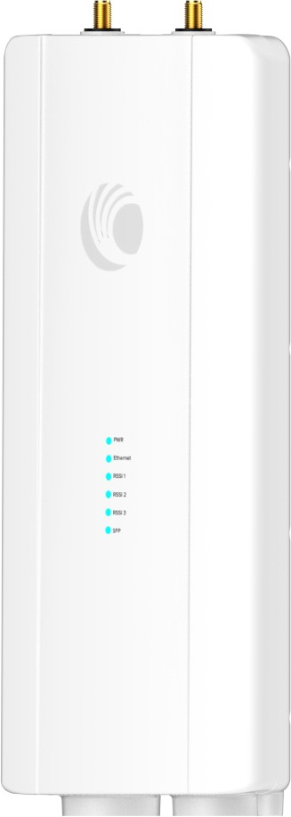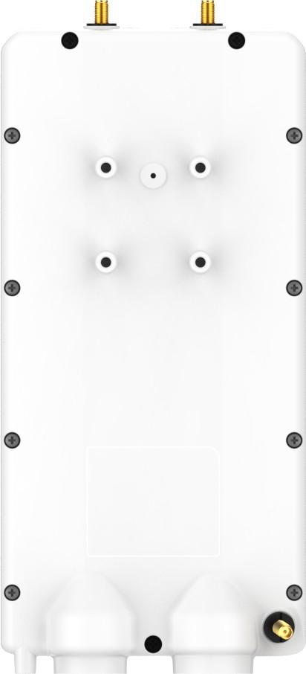

Figure 1: *ePMP 4600L*

A summary of the main ePMP 4600L characteristics are listed under Table 1. **Table 1: Main characteristics of the ePMP 4600L Series**

|  |  |
| --- | --- |
| **Characteristic** | **Value** |
| Topology | PTP and PMP |
| Wireless link condition | LoS, near LoS |
| Scheduler | WLR, TDD |
| Connectivity | Ethernet |
| Operating frequencies | Unlicensed bands, 6 GHz |
| Channel Bandwidth | 20 MHz, 40 MHz, 80 MHz, 160 MHz |
| Data rate | Up to 2+ Gbps Sector Throughput |

## Typical installation equipment

The ePMP™ solution includes integrated units, indoor power supply units/LAN injectors, cabling, and surge suppression equipment.

For more information about these components, including interfaces, specifications, and Cambium part numbers, see [System Hardware](System%20Hardware_Force4625.htm).



**Note**

This product meets the UL/cUL 62368 / IEC 62368 edition 2 specification, and the radio housings are designed to be rain-tight.

## Wireless operation

This section describes ePMP wireless link operating methods, modulation modes, power control, and security.

### MIMO

The Multiple-Input Multiple-Output (MIMO) technique protects against the fading and increases the probability of a received decoded signal being usable.

### Time-division duplexing

#### TDD cycle

ePMP links operate using Time Division Duplexing (TDD). In each TDD cycle, the Access Point (AP) determines which Subscriber Modules (SMs) transmit and the timing based on the configured downlink/uplink ratio (duty cycle). Three fixed downlink/uplink frame ratios are available: 75/25, 50/50, and 30/70.

### Adaptive modulation

ePMP 4600L can transmit a data over the wireless link using several different modulation modes ranging from 1024- QAM to QPSK. For a given channel bandwidth and TDD frame structure, each modulation mode transmits data at a fixed rate. Also, the receiver requires a given signal-to-noise ratio to successfully demodulate a given modulation mode. Although the more complex modulations such as 1024-QAM transmits data at a more higher rate than the less complex modulation modes, the receiver requires a much higher signal-to-noise ratio.

ePMP 4600L provides an adaptive modulation scheme where the receiver constantly monitors the quality of the received signal and notifies the far end of the link of the optimum modulation mode with which to transmit. In this way, optimum capacity is achieved at all times.

### Radar avoidance

In regions where the protection of radars is a part of the local regulations, ePMP must detect interference from radar- like systems and avoid co-channel operation with these systems.

To meet this requirement, ePMP implements the following features:

* The equipment can only transmits on available channels, of which there are none at initial power-up. The radar detection algorithm always scan a usable channel for 60 seconds for radar interference before making the channel an available channel.
* This compulsory channel scan means that there is at least 60 seconds service outage every time radar is detected, and that the installation time is extended by at least 60 seconds even if there is no radar on the channel.

There is a secondary requirement for bands requiring radar avoidance. Regulators have mandated that products provide a uniform loading of the spectrum across all devices. In general, this prevents operation with fixed frequency allocations as follows:

* ETSI regulations allow frequency planning of networks (as that has the same effect of spreading the load across the spectrum).
* The FCC allows the channels to be avoided if there is actual interference on them.



**Note**

When operating in a region that requires DFS, ensure that the AP is configured with alternate frequencies and the SM is configured to scan for these frequencies to avoid long outages.

### Encryption

ePMP supports optional encryption for data transmitted over the wireless link. The encryption algorithm used is the Advanced Encryption Standard (AES) with a 128-bit key size. AES is a symmetric encryption algorithm approved by

U.S. Government organizations (and others) to protect sensitive information.



**Note**

AES with a 256-bit key size is supported and can be ordered separately using SKU C050900S600A.

### Country codes

Some aspects of the wireless operation are controlled, enforced, or restricted according to a country code. ePMP country codes represent individual countries (for example Denmark) or regulatory regions (for example FCC or ETSI).

Country codes affect the following aspects of wireless operation:

* Maximum transmit power
* Radar avoidance (upcoming release)
* Frequency range



**Attention**

To avoid possible enforcement action by the country regulator, always operate links in accordance with the local regulations.

### Further reading on wireless operation

For information on planning wireless operation, see:

* The regulatory restrictions that affect radio spectrum usages, such as frequency range and radar avoidance are described in Radio spectrum planning.
* The safety specifications against which the ePMP is tested are listed under [Compliance with safety standards](Compliance%20with%20safety%20standards.htm#_Ref423114005) . It also describes how to keep RF exposure within safe limits.
* ePMP complies with the radio regulations that are enforced in various countries are explained in [Compliance](Compliance%20with%20radio%20regulations.htm#_Ref431206617) [with radio regulations](Compliance%20with%20radio%20regulations.htm#_Ref431206617).

For more information on configuring and operating the wireless link, see:

* The configuration parameters of the ePMP devices are described in [Using the menu options](Using%20the%20menu%20options.htm#_Ref530149147).

## System management

This section describes the ePMP management system, including the web interfaces, installation, alerts, upgrades, configuration, and management software.

### Management agent

ePMP equipment is managed through an embedded management agent. Management workstations, network management systems, or PCs can be connected to this agent using the module’s Ethernet port, SFP port, over the air (Subscriber Module connection through AP), or by using the device Wi-Fi management interface.

The management agent supports the following interfaces:

* Hypertext Transfer Protocol (HTTP)
* Hypertext Transfer Protocol Secure (HTTPs)
* Simple Network Management Protocol (SNMP)
* Network Time Protocol (NTP)
* System logging (Syslog)
* cnMaestro™ Cloud-based or On-premises Management System
* Dynamic Host Configuration Protocol (DHCP)

### Webserver

The ePMP management agent contains a web server. The web server supports access through the HTTP and HTTPs interfaces.

Web-based management offers a convenient way to manage the ePMP equipment from a locally connected computer or from a network management workstation connected through a management network, without requiring any special management software. The web-based interfaces are the only interfaces supported for the installation of ePMP, and the majority of ePMP configuration management tasks.

#### Identity-based user accounts

When identity-based user accounts are configured, a security officer can define from one to four user accounts, each of which may have one of the four possible roles:

* ADMINISTRATOR (default username/password is **admin**), who has full read and write permission.
* INSTALLER (default username/password is **installer**), who has permission to read and write parameters applicable to unit installation and monitoring.
* HOME (default username/password is **home**), who has permission only to access pertinent information for support purposes.
* READONLY (default username/password is **readonly**), who has permission to only view the Monitor page.

### SNMP

The management agent supports fault and performance management utilizing an SNMP interface. The management agent is compatible with SNMP v2c using one Management Information Base (MIB) file which is available for download from the Cambium Networks support site: <https://support.cambiumnetworks.com/files/epmp>.

### Network Time Protocol (NTP)

The clock supplies accurate date and time information to the system. It can operate with or without a connection to a network time server (NTP). Local time can be displayed by setting the time zone and daylight saving options on the Time web page.

If an NTP server connection is available, the clock can synchronize with the server time at regular intervals.

ePMP™ devices can receive NTP data from a CMM module or an NTP server configured in the system’s management network. The Time Zone option is configurable on the **Configure** > **System** page and can offset the received NTP time to match the operator’s local time zone.

### Software upgrade

Software upgrades can be issued through the radio web interface (**Tools** > **Software Upgrade**) or cnMaestro ([cloud.cambiumnetworks.com](https://cloud.cambiumnetworks.com/)). For software upgrades, visit: <https://support.cambiumnetworks.com/files/epmp>.

### Further reading on system management

For more information on system management, refer to [Operation and Troubleshooting](Operation%20and%20Troubleshooting.htm) section.

# System Hardware

This chapter describes the site planning and hardware components of an ePMP link. The following topics are described in this chapter:

* Factors to be considered when planning the proposed network is described under Site planning.
* The power supply hardware, part numbers, and specifications are described in Power supply.
* Cable standards and lengths are described in Ethernet cabling.
* Surge suppression requirements and recommendations are described in Surge suppression unit.

## Site planning

Conduct a site survey to ensure that the proposed sites meet the requirements defined in this section.

### Site installation

An ePMP site typically consists of a high supporting structure such as a mast, tower, or building for the devices. Find a location for the device that meets the following requirements:

* The equipment is high enough to achieve the best radio path.
* People can be kept a safe distance away from the equipment when it is radiating.
* The equipment is lower than the top of the supporting structure (tower, mast, or building) or its lightning air terminal.
* There is one Ethernet interface, a copper Cat5e connection from the device to the power supply, and network terminating equipment.

### Grounding and lightning protection

Structures, equipment, and people must be protected against power surges (typically caused by lightning) by conducting the surge current to the ground through a separate preferential solid path. The actual degree of protection required depends on local conditions and applicable local regulations. To adequately protect an ePMP installation, both ground bonding and transient voltage surge suppression are required.



**Warning**

Electro-magnetic discharge (lightning) damage is not covered under warranty. The recommendations in this guide, when followed correctly, give the user the best protection from the harmful effects of EMD. However, 100 percent protection is neither implied nor possible.

Details of lightning protection methods and requirements can be found in the international standards IEC 61024-1 and IEC 61312-1, the U.S. National Electric Code ANSI/NFPA No. 70-1984, or section 54 of the Canadian Electric Code.



**Note**

International and national standards take precedence over the requirements in this guide.

Figure 2: *Access Point installation diagram*

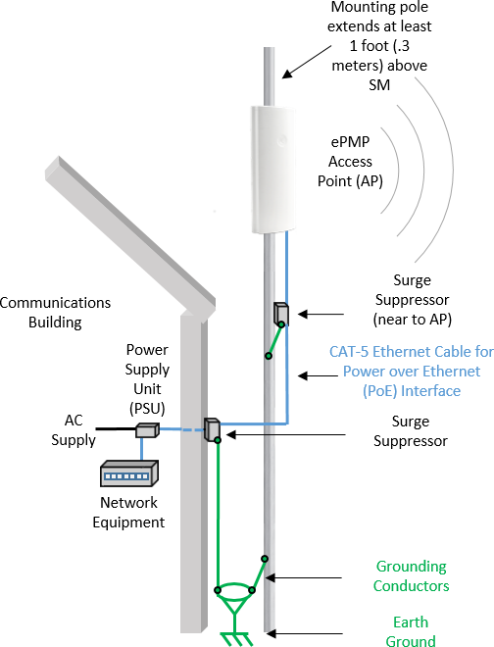

Figure 3: *Subscriber / Point-to-Point installation diagram*

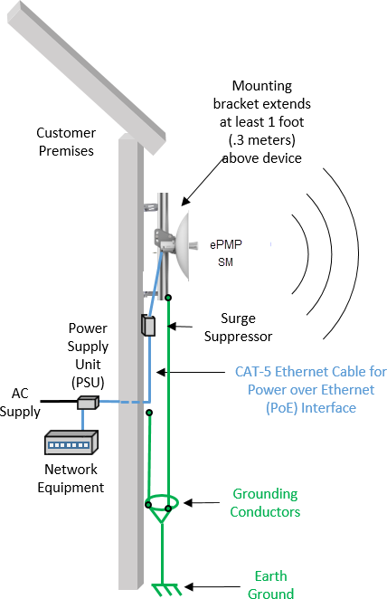

### Lightning protection zones

Use the rolling sphere method as shown in Figure 4 to determine where it is safe to mount the equipment. An imaginary sphere, typically 50 meters in radius, is rolled over the structure. Where the sphere rests against the ground and a strike termination device (such as a finial or ground bar), all the space under the sphere is considered to be in the zone of protection (Zone B). Similarly, where the sphere rests on two finials, the space under the sphere is considered to be in the zone of protection.

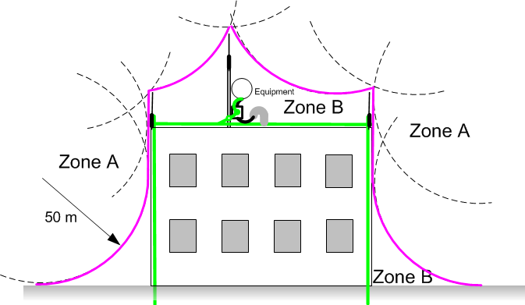

Figure 4: *Rolling sphere method to determine the lightning protection zones*

Assess locations on masts, towers, and buildings to determine if the location is in Zone A or Zone B:

* **Zone A**: In this zone a direct lightning strike is possible. Do not mount the equipment in this zone.
* **Zone B**: In this zone, direct EMD (lightning) effects are still possible, but mounting the equipment in this zone significantly reduces the possibility of a direct strike. Mount the equipment in this zone.



**Warning**

Do not mount the equipment in Zone A. Mounting the equipment in Zone A poses risk to the equipment, structures, and human lives.

### Electromagnetic Compatibility (EMC) compliance

ePMP complies with European EMC Specification EN301 489-1 with testing carried out to the detailed requirements of EN 301 489-17.

The EMC specification type approvals that is granted for ePMP are listed under Table 2. **Table 2: EMC emissions compliance**

|  |  |
| --- | --- |
| **Region** | **Specification (Type Approvals)** |
| USA | FCC CFR 47 Part 15 class B |
| Canada | RSS-210  RSS-247 |
| Europe | ETSI EN 301 489-1  ETSI EN 301 489-17 |

## ePMP 4600L Access Point

For details of the ePMP 4600L Access Point hardware, see:

* Description
* Part numbers
* Mounting bracket
* Interfaces
* Specifications
* Heater
* Wind loading
* Installation

* Software packages

### Description

The ePMP 4600L device is a self-contained transceiver unit that contains both radio and networking electronics. It is available with 2 X 2 MU-MIMO connectorized antenna. The MPE distance for FCC is 371 cm (Dish), 132 cm (Sector), and for IC is 20 cm.

ePMP 4600L is shown in Figure 5. Figure 5: *ePMP 4600L Access Point*

**

**Warning**

The operation of this device is prohibited on oil platforms, cars, trains, boats, and aircraft.

Operation of the transmitters in 5.925 GHz - 7.125 GHz band is prohibited for control of communications with the unmanned aircraft systems.

**

**Warning**

Devices shall not be used for control of or communications with unmanned aircraft systems.

Les appareils ne doivent pas être utilisés pour contrôler ou communiquer avec des systèmes d'aéronefs sans pilote.

**Warning**

Operation on oil platforms, automobiles, trains, maritime vessels, and aircraft shall be prohibited.

L'exploitation sur les plates-formes pétrolières, les automobiles, les trains, les navires maritimes et les aéronefs est interdite.

**Warning**

The antenna height shall be determined by the installer or operator of the standard-power access point or fixed client device, or by automatic means. This information are stored internally in the device.

Provision of accurate device information is mandatory.

La hauteur de l'antenne doit être déterminée par l'installateur ou l'opérateur du point d'accès à puissance standard ou de l'appareil client fixe, ou par des moyens automatiques. Ces informations doivent être stockées en interne dans l'appareil. La fourniture d'informations précises sur l'appareil est obligatoire.

### Part numbers

Select the correct regional variant to adhere to local licensing restrictions. Each of the parts listed in Table 3 includes the following items:

* One connectorized unit
* One power supply 1000/100 BASE-TX LAN injector
* One line cord

##### Table 3: ePMP 4600L Access Point part numbers

|  |  |
| --- | --- |
| **Cambium description** | **Cambium part number** |
| ePMP 4600L 6 GHz 2x2 Access Point Radio (ROW) (no cord) | C060940A051B |
| ePMP 4600L 6 GHz 2x2 Access Point Radio (ROW) (US cord) | C060940A151B |
| ePMP 4600L 6 GHz 2x2 Access Point Radio (ROW) (EU cord) | C060940A251B |
| ePMP 4600L 6 GHz 2x2 Access Point Radio (EU) (EU cord) | C060940A253B |
| ePMP 4600L 6 GHz 2x2 Access Point Radio (ROW) (UK cord) | C060940A351B |
| ePMP 4600L 6 GHz 2x2 Access Point Radio (EU) (UK cord) | C060940A353B |
| ePMP 4600L 6 GHz 2x2 Access Point Radio (ROW) (India cord) | C060940A451B |
| ePMP 4600L 6 GHz 2x2 Access Point Radio (India) (India Cord) | C060940A455B |

|  |  |
| --- | --- |
| **Cambium description** | **Cambium part number** |
| ePMP 4600L 6 GHz 2x2 Access Point Radio (ROW) (China cord) | C060940A551B |
| ePMP 4600L 6 GHz 2x2 Access Point Radio (ROW) (Brazil cord) | C060940A651B |
| ePMP 4600L 6 GHz 2x2 Access Point Radio (ROW) (Argentina cord) | C060940A751B |
| ePMP 4600L 6 GHz 2x2 Access Point Radio (ROW) (ANZ cord) | C060940A851B |
| ePMP 4600L 6 GHz 2x2 Access Point Radio (ROW) (South Africa cord) | C060940A951B |
| ePMP 4600L 6 GHz 2x2 Access Point Radio (ROW) (No PSU) | C060940AZ51B |
| ePMP 4600L 6 GHz 2x2 Access Point Radio (FCC/IC) (US cord) | C068940A152B |
| ePMP 4600L 6 GHz 2x2 Access Point Radio (Indonesia) (EU Cord) | C060940A256B |
| ePMP 4600L 6 GHz 2x2 Access Point | C068940P142B |
| ePMP External GPS Antenna | N000900L030A |

### Mounting bracket

The ePMP 4600L AP module is designed to be mounted with a pole-mounted using the mounting bracket provided in the box with the radio.

ePMP 4600L AP mounting bracket is shown in Figure 6

Figure 6: *ePMP 4600L Access Point module mounting bracket*

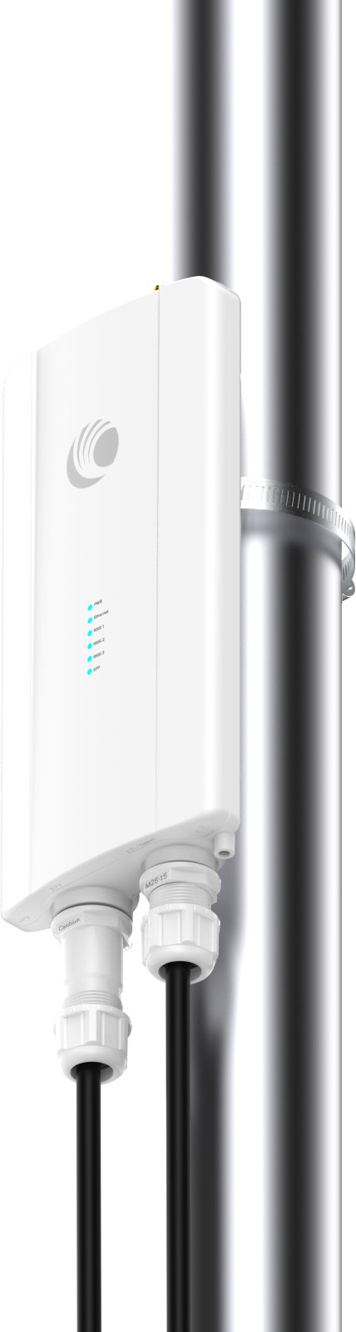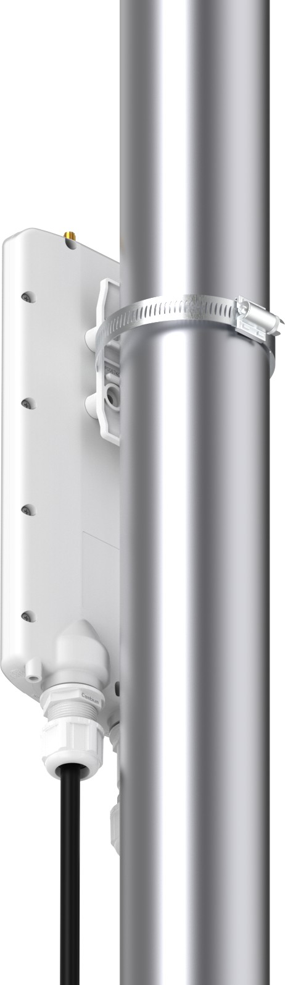

### Interfaces

The Ethernet port is located at the bottom of the unit. This interface is described in Table 4.

##### Table 4: ePMP 4600L Series – rear interfaces

|  |  |  |  |
| --- | --- | --- | --- |
| **Port name** | **Connector** | **Interface** | **Description** |
| Eth | RJ45 | PoE input | Power over Ethernet (PoE).  **Note**  All RJ45 Ethernet LAN cables used for providing power or are connected to power ports (PoE) must be UL certified with VW-1 markings. |
| 100/1000BASE-T Ethernet | Data |
| SFP | SFP | Optical or Copper Gigabit Ethernet | Management and/or data |

### Specifications

The ePMP 4600L connectorized module conforms to the specifications listed in Table 5 and Table 6.

The connectorized module meets the low-level static discharge specifications identified in Electromagnetic compatibility (EMC) compliance and provides internal surge suppression, but does not provide lightning suppression.

##### Table 5: ePMP 4600L Access Point physical specifications

|  |  |
| --- | --- |
| **Category** | **Specification** |
| Dimensions (Height x Width x Length) | 256 mm x 125 mm x 47 mm (10.1 in x 4.9 in x 1.9 in) |
| Weight | 0.73 kg (1.61 lb) without brackets |

##### Table 6: ePMP 4600L Access Point environmental specifications

|  |  |
| --- | --- |
| **Category** | **Specification** |
| Temperature | -40°C (-44°F) to +55°C (131°F) |
| Wind loading | 124 mph (200 kph) maximum. See [ePMP 4600L Access Point wind loading (Kg)](ePMP%204600%20Access%20Point%20wind.htm) for a full description |
| Humidity | 95% condensing |
| Environmental | IP67  **Note**  This product meets the UL/cUL 62368 / IEC 62368 edition 2 specification, and the radio housings are designed to be rain-tight. |

### Heater

At startup, if the ePMP 4600L AP module temperature is at or below 32°F (0°C), an internal heater is activated to ensure that the device can successfully begin operation. The unit’s heater is only activated when the unit is powered on and does not apply heat to the device after the start-up process is complete. When the unit temperature is greater than 32°F (0°C), the heater is deactivated, and the unit continues its start-up sequence.

The effect on device startup time at various temperatures is defined in Table 7.

##### Table 7: ePMP 4600L AP start-up times based on the ambient temperature

|  |  |
| --- | --- |
| **Initial temperature** | **Start-up time (from power on to operational)** |
| -22°F (-30°C) H | 20 minutes |
| -4°F (-20°C) | 6 minutes |
| 14°F (-10°C) | 2 minutes, 30 seconds |

### Wind loading

Ensure that the device and the structure on which it is mounted are capable of withstanding the prevalent wind speeds at a proposed ePMP site. Wind speed statistics are available from national meteorological offices.

The device and its mounting bracket are capable of withstanding wind speeds of up to 200 kph (124 mph).

Wind blowing on the device will subject the mounting structure to significant lateral force. The magnitude of the force depends on both wind strength and the surface area of the device. Wind loading is estimated using the following formulae:

Force (in kilograms) = 0.1045aV2

|  |  |
| --- | --- |
| **Where:** | **Is:** |
| a | the surface area in square meters |
| V | wind speed in meters per second |

Force (in pounds) = 0.0042Av2

|  |  |
| --- | --- |
| **Where:** | **Is:** |
| A | the surface area in square feet |
| V | wind speed in miles per hour |

### Installation



**Note**

A professional installation is required.

#### Package contents

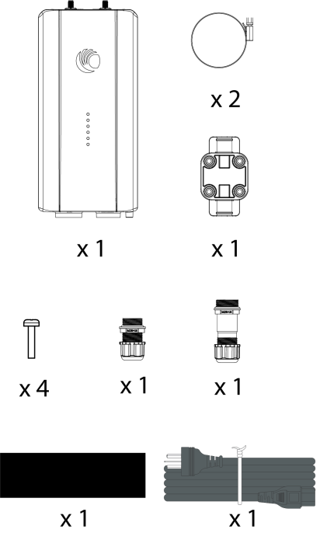

#### Installing ePMP 4600L

To install ePMP 4600L Access Point, perform the following steps:

1. Place the M8 nuts to antenna and tighten by applying 5.0 Nm torque.

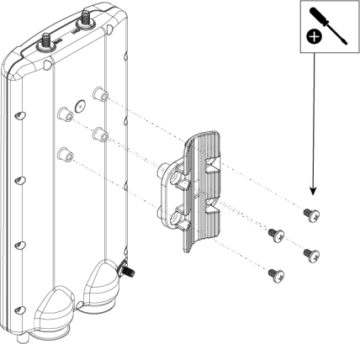

1. Assemble antenna to pole with rear pole bracket and secure it with M8 nut by applying 10.0 Nm torque.

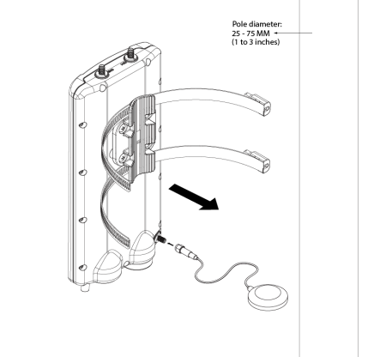

1. Connect the RF cables to third party horn or sector antenna.

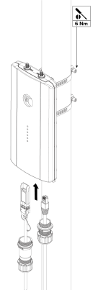

1. Connect the GPS SMA connector to the GPS antenna puck (included in the box).

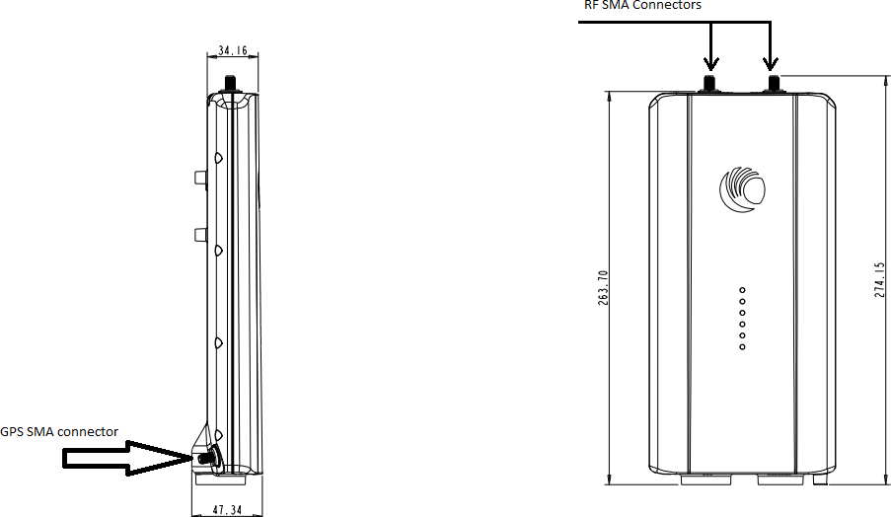

### Software packages

ePMP 4600L AP devices can be upgraded by downloading new software packages from the [Cambium Networks site](https://www.cambiumnetworks.com/) or by using cnMaestro. The software packages applicable to ePMP integrated radios are named:

* + ePMP-AX-v5.x.x.img (or higher version number)

## Power supply

For details of the ePMP power supply units, see:

* + [Power supply description](Power%20supply%20description.htm)
  + Power supply part numbers
  + Power supply interfaces
  + Power supply specifications

* + Power supply location considerations

### Power supply description

The power supply unit that is connected to the ePMP modules is rated for indoor use. The ePMP modules are installed outdoors and terminated to network equipment using Cat5e cables with RJ45 connectors. The Cat5e cables are plugged into an AC or DC power supply to inject Power over Ethernet (PoE) into the module. The Cat5e cables connected to the power supply transitioning from indoors to outdoors must be rated for outdoor use.



**Attention**

All RJ45 Ethernet LAN cables used for providing power or are connected to power ports (PoE) must be UL certified with VW-1 markings.

#### SFP

The SFP port is the longer gland. SFP and SFP+ are supported in this radio. To achieve the full potential of the radio, it is recommended to use 10G transceiver.

Table 8 describes the part numbers of SFPs from Cambium Networks that can be ordered as optional:

##### Table 8: SFP part numbers

|  |  |
| --- | --- |
| **Cambium description** | **Cambium part number** |
| 1G SFP MMF SX Transceiver, 850 nm (-40°C to 85°C) | SFP-1G-SX |
| 1G SFP SMF LX Transceiver, 1310 nm (-40°C to 85°C) | SFP-1G-LX |
| 1000 Base-T (RJ45) SFP Transceiver ( -40°C to 85°C) | SFP-1G-Copper |
| 10G SFP+ MMF SR Transceiver, 850 nm ( -40°C to 85°C) | SFP-10G-SR |
| 10G SFP+ SMF LR Transceiver, 1310 nm (-40°C to 85°C) | SFP-10G-LR |
| 10G Base-T (RJ45) SFP Transceiver ( 0°C to 70°C) | SFP-10G-Copper |

### Power supply part numbers

Each module requires one power supply and one power supply line cord (line cord included with radio device, refer to Table 9.

##### Table 9: Power supply part numbers

|  |  |  |
| --- | --- | --- |
| **Cambium description** | **Cambium part number** | **Device Compatibility** |
| POWER SUPPLY, 30W, 56V – Gbps support | N000000L034 | ePMP Access Point |



**Attention**

Each ePMP device must be powered by the corresponding power supply listed in Table 9. This product is intended to be supplied by a UL Listed and IEC certified Power Supply Unit marked **LPS** or **PS2** and providing power over the Ethernet (PoE) supply.

### Power supply interfaces

The power supply interfaces are illustrated in Figure 7 and described in and Table 10. Figure 7: *Power supply interfaces*

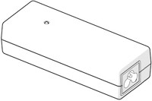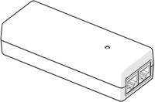

Power input

Gigabit Data

Gigabit Data + Power

##### Table 10: Power supply interface functions - N000000L034

|  |  |
| --- | --- |
| **Interface** | **Function** |
| Power input | Mains power input. |
| Power output | 56V |
| Gigabit Data + Power | RJ45 socket for connecting Cat5e cable to the radio.  **Note:** All RJ45 Ethernet LAN cables used for providing power or are connected to power ports (PoE) must be UL certified with VW-1 markings. |
| Gigabit Data | RJ45 socket for connecting Cat5e cable to the network. |

##### Table 11: Power Supply LED functions

|  |  |
| --- | --- |
| **LED** | **Function** |
| Power (Green) | Power supply detection |

### Power supply specifications

The ePMP power supply conforms to the specifications listed in Table 12, Table 13, and Table 14. **Table 12: Power supply physical specifications**

|  |  |
| --- | --- |
| **Category** | **Specification** |
| Dimensions (H x W x D) | 14 x 6.5 x 3.6 cm (5.5 x 2.55 x 1.42 in) |
| Weight | 0.26 lbs |

##### Table 13: Power supply environmental specifications

|  |  |
| --- | --- |
| **Category** | **Specification** |
| Ambient Operating Temperature | 0°C to +40°C |
| Humidity | 20% - 90% |

##### Table 14: Power supply electrical specifications

|  |  |
| --- | --- |
| **Category** | **Specification** |
| AC Input | 100 to 240 VAC |
| Efficiency | Meets Energy Level 6 |
| Over Current Protection | Short circuit, with auto-recovery |
| Hold uptime | 10 ms minimum at maximum load, 120 VAC |

### Power supply location considerations

Find a location for the power supply that meets the following requirements:

* + The power supply is rated for indoor use and can be mounted on a wall or other flat surface.
  + The power supply must be kept dry, with no possibility of condensation, flooding, or rising dampness.
  + The power supply can be accessed to view status indicators.
  + The power supply can be connected to the ePMP module drop cable and network terminating equipment.
  + The power supply can be connected to a mains or DC power supply that meets the requirements defined in Table 14.

## Ethernet cabling

For more information on the Ethernet cabling components of an ePMP installation, see:

* + Ethernet standards and cable lengths

* + Outdoor Cat5e cable

### Ethernet standards and cable lengths

All configurations require a copper Ethernet connection from the power supply port to the power supply and network terminating equipment.



**Attention**

All cables used for outdoor installations must be suitable to be used for that environment and rated accordingly.

For each power supply, the maximum permitted drop cable length is specified in Table 15.

##### Table 15: Power supply drop cable length restrictions

|  |  |  |
| --- | --- | --- |
| **Part number** | **Description** | **Maximum cable length (*1)** |
| N000900L001A | Power Supply for Radio with Gigabit Ethernet (no cord) | 330 feet (100m) |

(*1) The maximum length of Ethernet cable from the device to the network device needs to follow standards. If the power supply is not the network device the cable from the power supply to the network device must be included in the total maximum cable length.

### Outdoor Cat5e cable

#### Cambium Industrial Cable

Cambium Industrial Cable uses 24-gauge solid bare copper conductors, covered by bonded-pair polymer insulation. The conductors are protected by double-layer shielding consisting of a solid foil layer under the braided tinned copper mesh, providing excellent shielding while maximizing flexibility. The cable is jacketed by industrial-grade UV-resistant, abrasion-resistant, and oil-resistant PVC.

Cambium’s Industrial RJ45 connectors are specifically designed to work optimally with Cambium Industrial Cable.

The connectors are fully shielded with integrated strain relief for greater pull strength, utilize a staggered contact design that minimizes crosstalk, and maximizes electrical performance, and the contacts are plated with 50 micro-inch thick 24-carat gold, exceeding TIA-1096 specifications and ensuring the best possible connection and oxidation resistance.

Industrial-grade cable by Cambium Networks is well suited for high-quality durable installations of subscriber modules, APs, and enterprise point-to-point links and in tactical non-permanent deployments of infrastructure.

##### Table 16: Cambium Industrial Cable part numbers

|  |  |
| --- | --- |
| **Cambium description** | **Cambium part number** |
| Industrial Grade CAT 5 Cable 50 meter unterminated | N000000L106A |
| Industrial Grade CAT 5 Cable 100 meter unterminated | N000000L106A |
| Industrial Grade CAT 5 Cable 300 meter unterminated | N000000L108A |
| Industrial Grade RJ45 Connector 100 Pack | C000000L109A |
| Termination Tool for C000000L109A RJ45 connectors | C000000L110A |



**Attention**

All RJ45 Ethernet LAN cables used for providing power or are connected to power ports (PoE) must be UL certified with VW-1 markings.

## Surge suppression unit

Structures, equipment, and people must be protected against power surges (typically caused by lightning) by conducting the surge current to the ground via a separate preferential solid path.

The actual degree of protection required depends on local conditions and applicable local regulations. To adequately protect an ePMP installation, both ground bonding and transient voltage surge suppression are required.

Network operators should always follow best practices for grounding and lightning protection. Doing so will minimize network outages and reduce the associated costs of tower climbs and equipment repair/replacement.



**Note**

Lightning-prone installations can be improved by:

* Installing a surge suppressor near the device (transient surge suppression)
* Grounding the device to the pole (ground bonding)
* Lowering the device/dish such that it is not the highest metallic object on the pole.

### Gigabit Ethernet Surge Suppressor

The Gigabit Ethernet surge suppressor is critical for lightning protection to minimize the potential for damage.

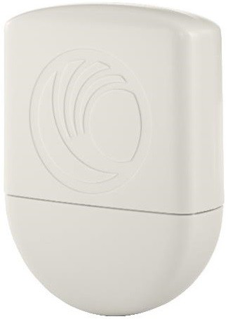

Figure 8: *Gigabit Ethernet Surge Suppressor*

##### Table 17: Surge suppressor part numbers

|  |  |  |
| --- | --- | --- |
| **Cambium description** | **Cambium part number** | **Device Compatibility** |
| Gigabit Surge Suppressor (56V) | C000000L033 | ePMP Access Points |



**Attention**

Choose the 56V surge suppressor option based on your installed device power rating. Installing a 30V surge suppressor for a 56V device or a 56V surge suppressor for a 30V device may result in inadequate surge protection. For more details, refer to Table 17.

# Regulatory Information

This section describes planning of the ePMP links to conform to the regulatory restrictions that apply in the country of operation.



**Attention**

The user must ensure the ePMP product operates in accordance with local regulatory limits.



**Note**

Contact the applicable radio regulator to check if the registration of the ePMP link is required.

## General wireless specifications

The wireless specifications that apply to ePMP 802.11ax variants are listed under Table 18. The wireless specifications that are specific to each frequency variant are listed in Table 19.

##### Table 18: Wireless specifications (all variants)

|  |  |
| --- | --- |
| **Item** | **Specification** |
| Channel selection | Manual selection (fixed frequency)  Automatic Channel Selection |
| Manual power control | To avoid interference with other users of the band, maximum power can be set lower than the default power limit. |
| Maximum transmit power | 0 to +28 dBm (combined, to regional EIRP limit) |
| Duplex scheme | Adaptive TDD |
| Over-the-air encryption | AES |
| Error Correction | FEC |

##### Table 19: Wireless specifications, 6 GHz band

|  |  |
| --- | --- |
| **Item** | **6 GHz** |
| RF band (GHz) | 5725 - 7125 MHz |
| Channel bandwidth | 20 MHz, 40 MHz, 80 MHz, or 160 MHz |
| Typical antenna gain | Sector antenna – 18 dBi |
| Antenna 3 dB Beamwidth | Sector antenna: 65° azimuth, 5° elevation |

## Regulatory limits

The local regulator may restrict frequency usage and channel width and may limit the amount of conducted or radiated transmitter power.

Many countries impose EIRP limits (allowed EIRP) on products operating in the bands used by the ePMP Series. For example, in the 5 GHz band in Europe, these limits are calculated as follows:

* In the 5.8 GHz band (5725 MHz to 5875 MHz), the EIRP must not exceed the lesser of 36 dBm or (23 + 10 x Log Channel width in MHz) dBm.

Some countries (for example the USA) impose conducted power limits on products operating in the 5 GHz band.

## Conforming to the limits

Ensure the link is configured to conform to the local regulatory requirements by configuring the correct country code (located in the web management interface, under **Configure** > **Radio**). In the following situations, the country code does not prevent the operation automatically outside the regulations:

* When operating in ETSI regions, it is required to enter a license key in the ePMP web management interface to unlock valid country-specific frequencies. This key can be obtained from <https://support.cambiumnetworks.com/licensekeys/epmp>.

## Available spectrum

The available spectrum for the operation depends on the region. When configured with the appropriate country code, the unit allows operation on those channels only which are permitted by the regulations.

Certain regulations have allocated certain channels as unavailable for use:

* Some European countries have allocated, part of the 5.8 GHz band to Road Transport and Traffic Telematics (RTTT) systems.

Where regulatory restrictions apply to certain channels, these channels are barred automatically by the use of the correct country code. For example, at 5.8 GHz in some European countries, the RTTT band 5795 MHz to 5815 MHz is barred. With the appropriate country code configured for this region, the ePMP does not operate on channels within this band.

The number and identity of channels barred by the license key and country code are dependent on the channel bandwidth.

## Channel bandwidth

Select the required channel bandwidth for the link. The selection depends on the ePMP frequency variant and country code.

The wider a channel bandwidth the greater is its capacity. As narrower channel bandwidths take up less spectrum, selecting a narrow channel bandwidth may be a better choice when operating in locations where the spectrum is very busy.

Both ends of the link must be configured to operate on the same channel bandwidth.

## Electromagnetic Compatibility (EMC) compliance

ePMP complies with European EMC Specification EN301 489-1 with testing carried out to the detailed requirements of EN 301 489-17.

The EMC specification type approvals that is granted for ePMP are listed under Table 20.

##### Table 20: EMC emissions compliance

|  |  |
| --- | --- |
| **Region** | **Specification (Type Approvals)** |
| USA | FCC CFR 47 Part 15 class B |
| Canada | RSS-210  RSS-247 |
| Europe | ETSI EN 301 489-1  ETSI EN 301 489-17 |

## Compliance with safety standards

This section lists the safety specifications against which the ePMP is tested and certified. ePMP complies with global Electrical Safety specifications, primarily IEC 62368-1, IEC 60950-22, UL 62368-1, UL 60950-22.

For RF exposure limits, ePMP 4600L has a safe distance of 105 cm in USA, 65 cm in Europe, and 20 cm in Canada.

Cambium Networks complies with the European Regulation 2023/988 of 10 May 2023 on General Product Safety. EU Authorized Representative: Cambium Networks Europe B.V., Muiderstraat 1, 1011PZ Amsterdam, Netherlands.

Contact Information: [GPSR@cambiumnetworks.com](mailto:GPSR@cambiumnetworks.com).

# Glossary

|  |  |
| --- | --- |
| **Term** | **Definition** |
| AES | Advanced Encryption Standard |
| ANSI | American National Standards Institute |
| CINR | Carrier to Interference plus Noise Ratio |
| CMM | Cluster Management Module |
| DFS | Dynamic Frequency Selection |
| EIRP | Equivalent Isotropically Radiated Power |
| EMC | Electromagnetic Compatibility |
| EMD | Electromagnetic Discharge |
| ETH | Ethernet |
| ETSI | European Telecommunications Standards Institute |
| FCC | Federal Communications Commission |
| FEC | Forward Error Correction |
| GUI | Graphical User Interface |
| HTTP | Hypertext Transfer Protocol |
| IC | Industry Canada |
| IEEE | Institute of Electrical and Electronics Engineers |
| IP | Internet Protocol |
| LAN | Local Area Network |
| LED | Light Emitting Diode |
| LoS | Line of Sight |
| MIMO | Multiple In Multiple Out |
| MIR | Maximum Information Rate |
| MU-MIMO | Multi-User Multiple In Multiple Out |
| MTU | Maximum Transmission Unit |
| nLOS | Near Line of Sight |
| NTP | Network Time Protocol |
| OFDM | Orthogonal Frequency Division Multiplexing |
| PC | Personal Computer |
| PMP | Point to Multipoint |
| PTP | Point to Point |

|  |  |
| --- | --- |
| **Term** | **Definition** |
| QAM | Quadrature Amplitude Modulation |
| QPSK | Quadrature Phase Shift Keyed |
| RF | Radio Frequency |
| RMA | Return Merchandise Authorization |
| RSSI | Received Signal Strength Indication |
| RTTT | Road Transport and Traffic Telematics |
| RX | Receive |
| SAR | Standard Absorption Rate |
| SNMP | Simple Network Management Protocol |
| SW | Software |
| TDD | Time Division Duplex |
| TDWR | Terminal Doppler Weather Radar |
| TX | Transmit |
| UNII | Unlicensed National Information Infrastructure |
| URL | Uniform Resource Locator |

# Cambium Networks

Cambium Networks delivers wireless communications that work for businesses, communities, and cities worldwide. Millions of our radios are deployed to connect people, places and things with a unified wireless fabric that spans multiple standards and frequencies of fixed wireless and Wi-Fi, all managed centrally via the cloud. Our multi-gigabit wireless fabric offers a compelling value proposition over traditional fiber and alternative wireless solutions. We work with our Cambium certified ConnectedPartners to deliver purpose-built networks for service provider, enterprise, industrial, and government connectivity solutions in urban, suburban, and rural environments, with wireless that just works.

|  |  |
| --- | --- |
| User Guides | <http://www.cambiumnetworks.com/guides> |
| Technical training | <https://learning.cambiumnetworks.com/learn> |
| Support website (enquiries) | [https://support.cambiumnetworks.com](https://support.cambiumnetworks.com/) |
| Main website | [http://www.cambiumnetworks.com](http://www.cambiumnetworks.com/) |
| Sales enquiries | [solutions@cambiumnetworks.com](mailto:solutions@cambiumnetworks.com) |
| Warranty | <https://www.cambiumnetworks.com/support/standard-warranty/> |
| Telephone number list | <http://www.cambiumnetworks.com/contact-us/> |
| Address | Cambium Networks Limited, Unit B2, Linhay Business Park, Eastern Road,  Ashburton, Devon, TQ13 7UP United Kingdom |

 [www.cambiumnetworks.com](http://www.cambiumnetworks.com/)

Cambium Networks and the stylized circular logo are trademarks of Cambium Networks, Ltd. All other trademarks are the property of their respective owners.

© Copyright 2025 Cambium Networks, Ltd. All rights reserved.